
Cisco at ECOC 2026

Cisco Featured Solutions in Ethernet Alliance 2026 Interoperability Demonstration:
- 8212-48FH-M Router
- 8122X-64EF-O Switch
- N9364E-SG2X-O Switch
- Transceiver Modules (OSFP and QSFP-DD 800G ZR+, QSFP-DD 400G ZR+, QSFP-DD 400G/800G, OSFP 800G)

Cisco believes in open networking and is proud to be actively involved in driving standards and multi-vendor interoperability collaborations that support rapid time to market and economies of scale. Cisco has made significant contributions to multiple industry standards efforts including IEEE 802.3, OIF, LPO MSA, 100G Lambda MSA, QSFP-DD MSA, and OSFP MSA. In many cases, Cisco initiated and co-led these projects as well as drove the technical direction to ensure our customers’ interoperability requirements were met.

8212-48FH-M Router
The Cisco 8212-48FH-M is a high-bandwidth router designed for various networking roles offering maximum performance and scalability. It leverages a Router-on-Chip (RoC) architecture, providing comprehensive routing capabilities with a single Cisco Silicon One™ P100 NPU. The 8212-48FH-M offers up to 19.2 Tbps of network bandwidth while consuming less power compared to similar systems, all within a compact 2 RU form factor. The port density allows for flexible port rate configurations supporting 24 800G QSFP-DD800 or 48 400G QSFP-DDports with MACsec, making it adaptable to various network demands. Additionally, the router supports advanced automation capabilities with Cisco's IOS XR and Crosswork Network Automation, ensuring efficient network management and operation.
Cisco 8212-48FH-M Router
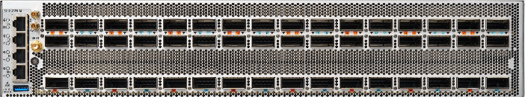

8122X-64EF-O Switch / N9364E-SG2X-O
The Cisco 8122X-64EF-O and N9364E-SG2X-O deliver scalable, programmable, high-radix switching for large-scale AI/ML environments in a compact 2RU form factor. Each platform features 64 × 800G OSFP ports, LPO support, and 51.2 Tbps of forwarding capacity powered by a single Cisco Silicon One™ G200 Series NPU. The 8122X-64EF-O supports SONiC. The N9364E-SG2X-O supports Cisco SONiC and NX-OS and is managed through Nexus One. Both platforms provide the scale and performance required for massive AI clusters.
Cisco 8122X-64EF-O / Nexus N9364E-SG2X-O Switch
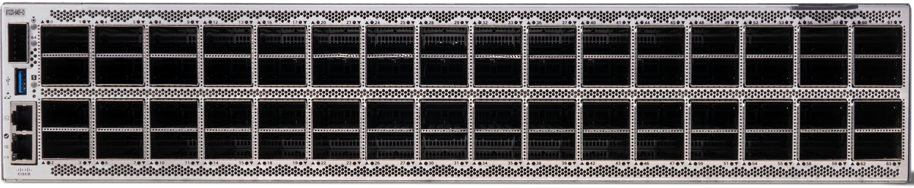

Coherent Pluggable Optics
Cisco offers the highest quality, market leading 400G ZR/ZR+ and 800G ZR/ZR+ coherent pluggable optics in QSFP-DD and OSFP form factors. They provide 100% network coverage from access to ultra long-haul applications in Routed Optical Networking architectures with reaches up to 3000km. They are powered by coherent DSPs and silicon photonics leveraging 3D Siliconization that delivers a compact low power consumption device. Key use cases include edge/access, DCI, AI Scale-Across, cloud, & long haul.

QSFP-DD and OSFP 800G Transceivers
The Cisco OSFP 800G transceiver modules provide 800GE, 2x 400GE, 4x 200GE, and 8x 100GE connectivity options, complying with the Octal Small Form Factor Pluggable (OSFP) MSA for pluggable transceivers. The modules comply with the OSFP configuration with integrated and riding heat sinks. These transceivers are used in AI applications for both front-end and back-end networks as well as other data center applications.

The Cisco QSFP-DD 800G portfolio delivers 8x100G and 2x400G Quad Small Form-Factor Pluggable Double-Density (QSFP-DD) modules, offering customers super-high-density pluggable transceivers along with the flexibility of 400 Gigabit Ethernet and 100 Gigabit Ethernet connectivity options. The Cisco QSFP-DD 400G portfolio offers customers a wide variety of high-density transceiver modules and the flexibility of 400 Gigabit Ethernet connectivity options. These optics are hot-swappable, allowing for easy installation and replacement without disrupting network operations and backward compatibility to lower-speed QSFP pluggable modules and cables. They are interoperable with other IEEE-compliant interfaces, ensuring compatibility while providing superior performance, quality, and reliability.

Cisco and Ethernet Alliance
Cisco is proud to apply our domain expertise and industry acumen, working with the Ethernet Alliance to demonstrate and showcase innovations in networking and optics. Our leadership within the Ethernet Alliance demonstrates our commitment to driving multi-vendor interoperability and accelerating deployment-ready products into high-performance networks.
For more information on Cisco’s solutions, go to www.cisco.com or OFC booth #1870.

©2026 Cisco Systems, Inc. and/or its affiliates. All rights reserved.

